Session 2

1. Open Zomato.com in Chrome, press F12 to open DevTools, and use the device toolbar to simulate the site on iPhone 12, iPad, and a standard desktop. List 3 layout or UI changes you observe between these views.

Three layout changes to record
UI element | iPhone 12 | iPad | Desktop
Navigation | Compact or simplified | More links may fit | Full navigation may be visible
Content layout | Single column or horizontal sections | Wider cards or multiple columns | Multi-column grid
Spacing and sizing  I phone 16 | Compact spacing and full-width controls | Medium spacing | Wider margins and larger content areas
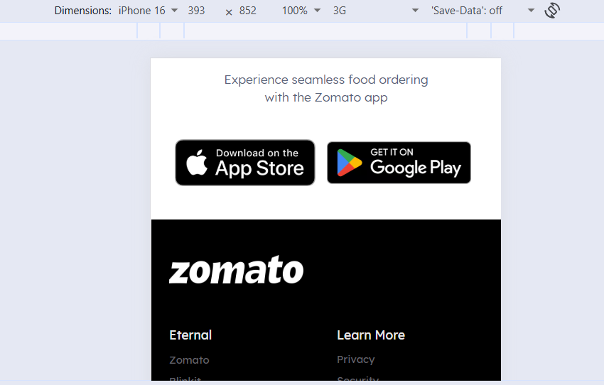

I pad

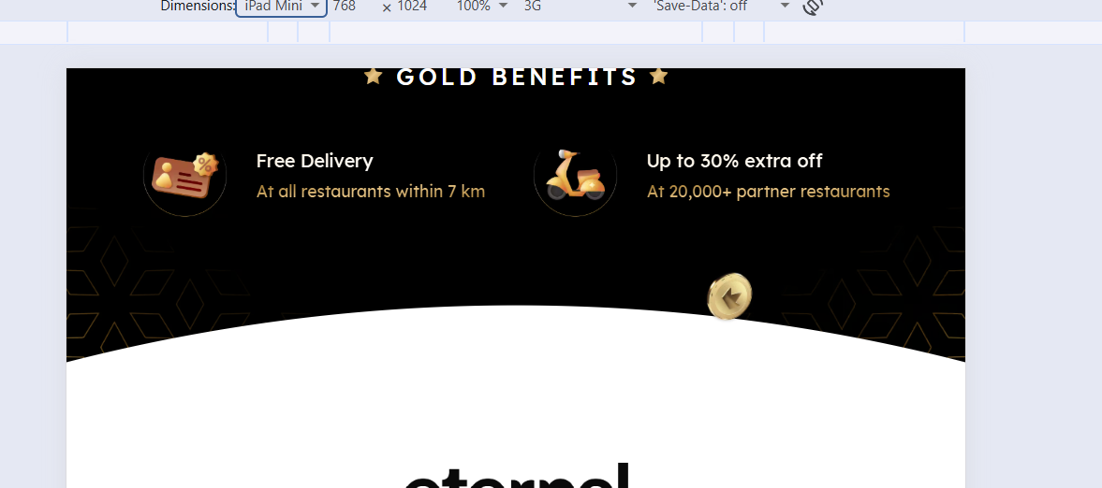

Desktop

2.

Pick any Flipkart product page and resize your browser window from desktop width down to mobile width. Note at which pixel widths (breakpoints) major layout shifts happen (e.g., menu collapses, grid changes to list). List the breakpoints and describe what changes at each.

2. Flipkart — Responsive breakpoints
Website: Flipkart Tool: Chrome DevTools and browser window resizing

Procedure
- Open any Flipkart product page.
- Start with a desktop viewport of approximately 1440 px wide.
- Gradually reduce the viewport width.
- Record the width at which the header, product images, product details, and purchase buttons change position.
- Repeat by increasing the width to confirm the transition points.

Breakpoint observation table
The following values are suggested test widths, not verified Flipkart breakpoints. Use them to locate the actual transitions on the selected product page.

Viewport width | Layout behavior to check
1200 px and above | Desktop header, product image and details side by side, full navigation
992–1199 px | Reduced spacing, narrower product details, possible navigation compression
768–991 px | Tablet layout; product columns may shrink or rearrange
576–767 px | Compact navigation, reduced margins, potentially stacked product information
Below 576 px | Mobile-style header, narrow content, stacked sections, prominent purchase controls

3. Open Myntra.com in both Chrome and Firefox browsers on your laptop. Take screenshots of the homepage in both browsers at desktop size and compare them. Identify and describe 2 differences in how elements (fonts, buttons, images, etc.) are rendered.

3. Myntra — Chrome vs Firefox comparison
Website: Myntra Browsers: Google Chrome and Mozilla Firefox Test size: 1440 × 900 CSS pixels

Procedure
- Open the Myntra homepage in Chrome and capture a screenshot.
- Open the same page in Firefox at the same viewport size.
- Use the same zoom level, preferably 100%.
- Compare the header, typography, banners, product images, and buttons.
- Ensure both screenshots are taken with the same page state, including any cookie or location prompts.

Chrome reference
Check navigation spacing, font weight, banner sizing, and image cropping.

Firefox reference
Compare the same elements at an identical viewport and zoom level. These reference images are illustrative, not actual browser captures from this test.

Two rendering differences to investigate
Element | Possible difference | How to verify
Fonts and text | Slight differences in font rendering, glyph width, or antialiasing may change the appearance of navigation labels. | Compare text width, line height, weight, and wrapping.
Images and buttons | Differences in image sizing, cropping, button dimensions, or alignment may appear if CSS or native control styles render differently. | Compare banner edges, card dimensions, button height, and horizontal alignment.
Conclusion: Modern Chrome and Firefox usually render standards-compliant layouts similarly. Do not report either difference as an observed defect unless it is visible in the actual screenshots. A difference may also be caused by font loading, caching, browser zoom, or different page content rather than the browser engine itself.

4. Use BrowserStack (or CrossBrowserTesting) to test BookMyShow.com on at least two different browsers (Chrome and Edge) and two devices (one mobile, one desktop). Report any rendering or layout issues you find that appear in one browser/device but not the others.<br><br><em><strong>Hint:</strong> Focus on navigation menus, banners, and buttons for visible differences.</em>

4. BookMyShow — Cross-browser and cross-device testing
Website: BookMyShow Testing tool: BrowserStack Live or CrossBrowserTesting

Test matrix
Test the same homepage on four combinations. Use the same location, page state, and approximate viewport dimensions wherever possible.
Test | Browser | Device / viewport
1 | Chrome | Desktop, 1440 × 900
2 | Edge | Desktop, 1440 × 900
3 | Chrome | Mobile, 390 × 844
4 | Edge | Mobile, 390 × 844

Issues to look for
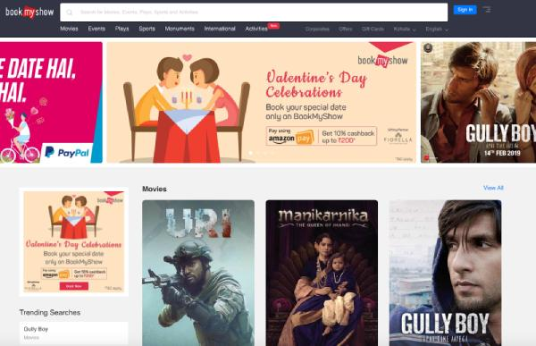
Issue 1: Navigation menu
Potential symptom: Menu links, location selection, or search controls become crowded or misaligned.
Test: Compare the header across Chrome and Edge, then check whether it collapses appropriately on mobile.
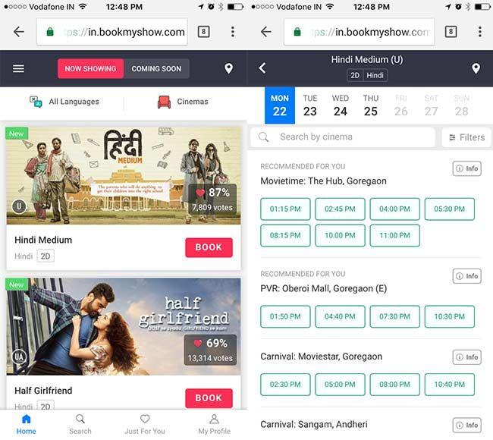
Issue 2: Movie banners and posters
Potential symptom: Banner cropping, inconsistent card widths, or posters overflowing their containers.
Test: Compare image proportions and horizontal scrolling on mobile versus desktop.
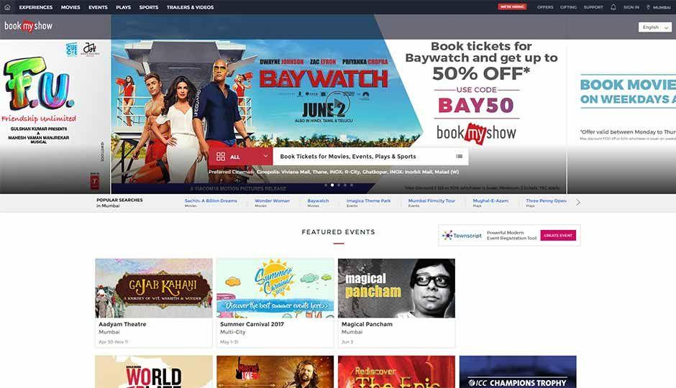
Issue 3: Buttons and interactive controls
Potential symptom: Small tap targets, clipped button text, or misaligned booking controls.
Test: Check that buttons remain readable, clickable, and properly spaced on both browsers.

Results table
Use this table to document the actual outcome of your four tests.
Feature | Chrome desktop | Edge desktop | Chrome mobile | Edge mobile
Navigation | Record result | Record result | Record result | Record result
Banner and posters | Record result | Record result | Record result | Record result
Buttons | Record result | Record result | Record result | Record result
Horizontal overflow | Record result | Record result | Record result | Record result
Conclusion: BrowserStack helps determine whether a problem is browser-specific or caused by a responsive layout. Since these tests have not been executed here, no actual BookMyShow rendering defect can be confirmed.

5.

Identify 5 responsive UI issues on any one of your favorite apps' web versions (e.g., Spotify, Instagram, Swiggy) using Chrome DevTools device simulation. For each issue, describe the problem, the device size where it appears, and suggest a possible fix.

Spotify — Five responsive UI issues
Website: Spotify Web Player Tool: Chrome DevTools device simulation
The following are five potential issues to investigate. They are illustrative test cases, not confirmed defects in Spotify's current website.
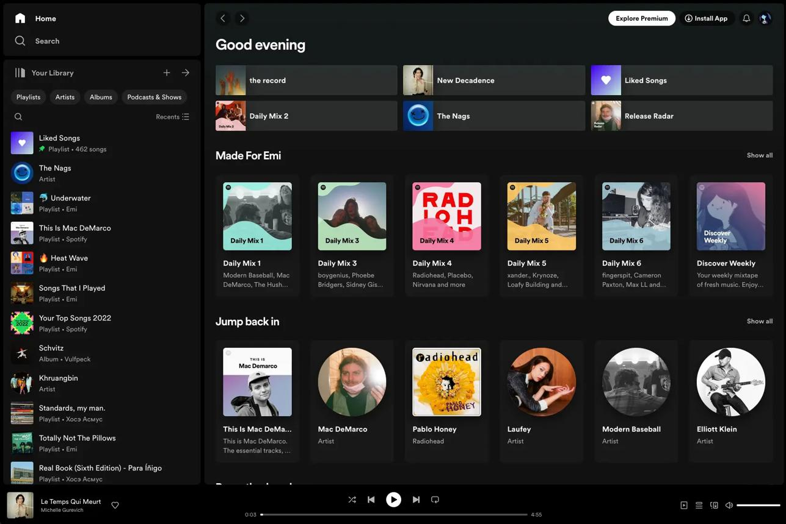
Issue 1: Sidebar takes up too much space
- Device size: Tablet, 768 × 1024.
- Problem to check: The sidebar may leave insufficient room for playlist content.
- Suggested solution: Collapse the sidebar into an icon-only rail or provide a toggle.
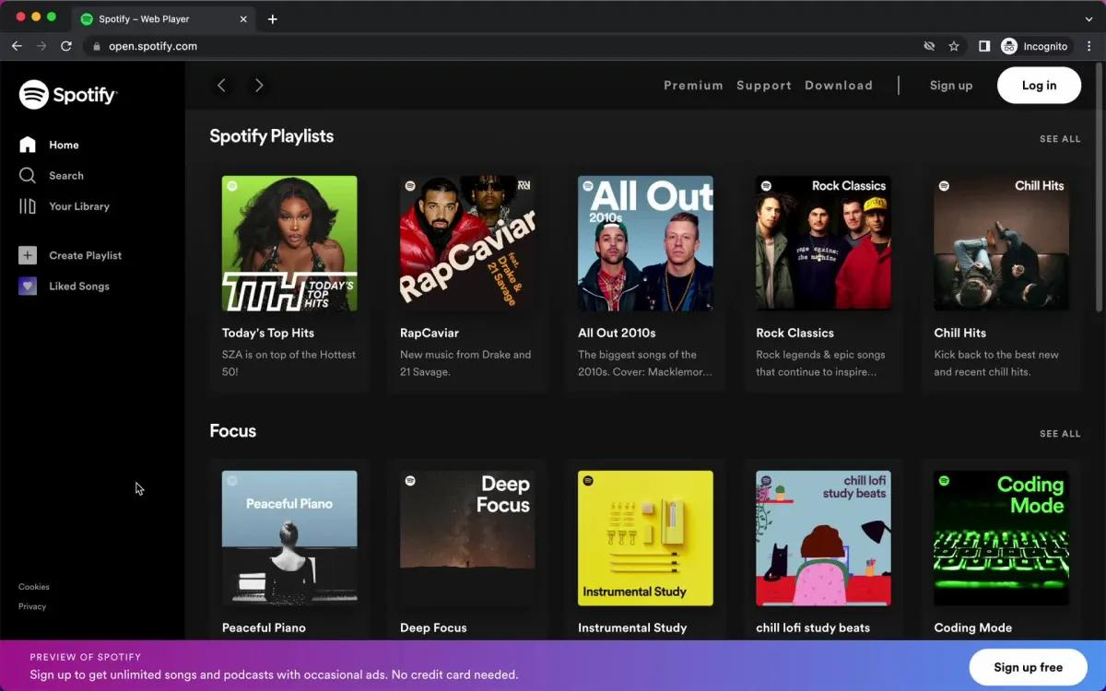
Issue 2: Album cards become too narrow
- Device size: Small tablet, 600 × 800.
- Problem to check: Multiple columns may squeeze album titles and artwork.
- Suggested solution: Reduce the number of grid columns using responsive CSS.
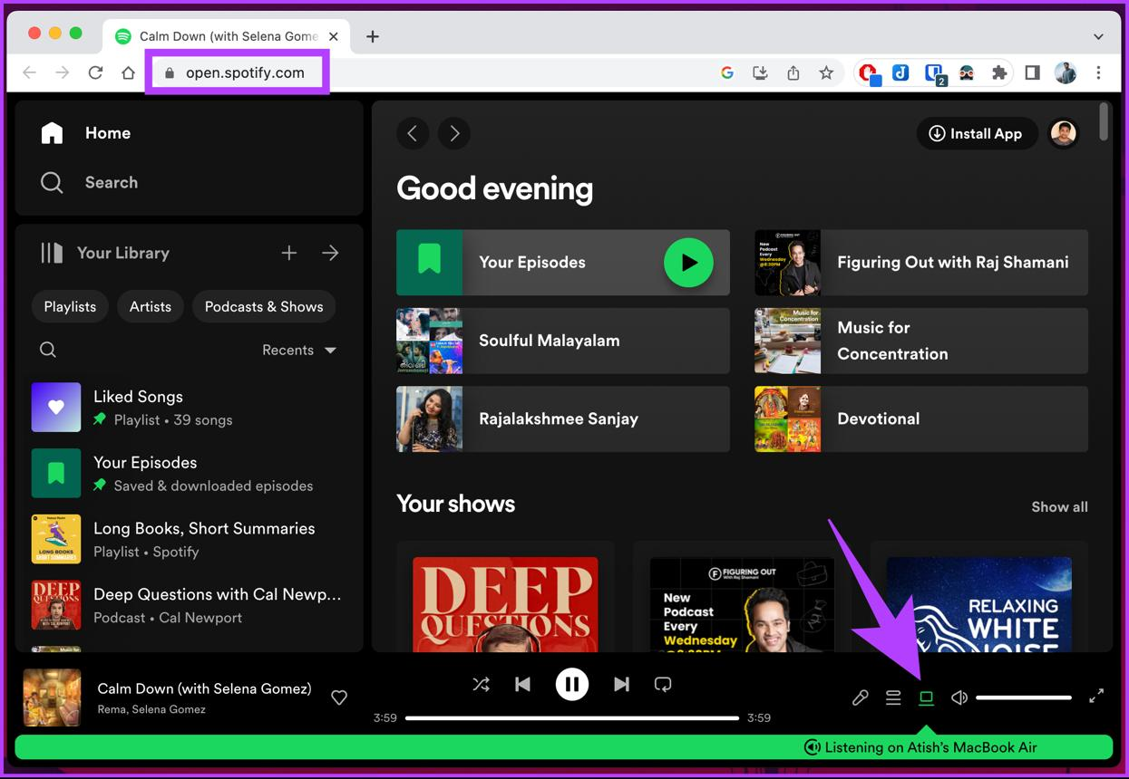
Issue 3: Playback controls overlap
- Device size: Mobile-width viewport, 375 × 812.
- Problem to check: Playback controls, the progress bar, and track information compete for space.
- Suggested solution: Hide secondary controls and prioritize play, pause, and track navigation.
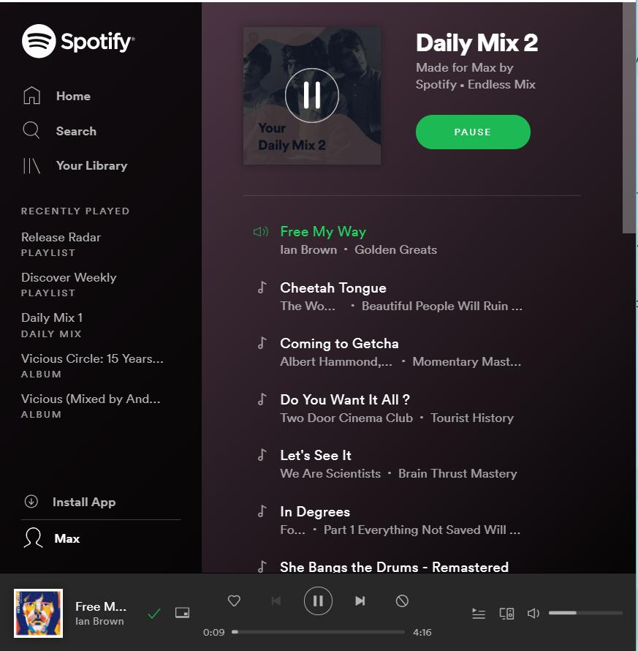
Issue 4: Long song or playlist titles are clipped
- Device size: Mobile, 320 × 568.
- Problem to check: Long text overlaps icons or extends outside a card.
- Suggested solution: Allow wrapping where appropriate, use ellipsis for constrained labels, and set min-width: 0 on flexible elements.
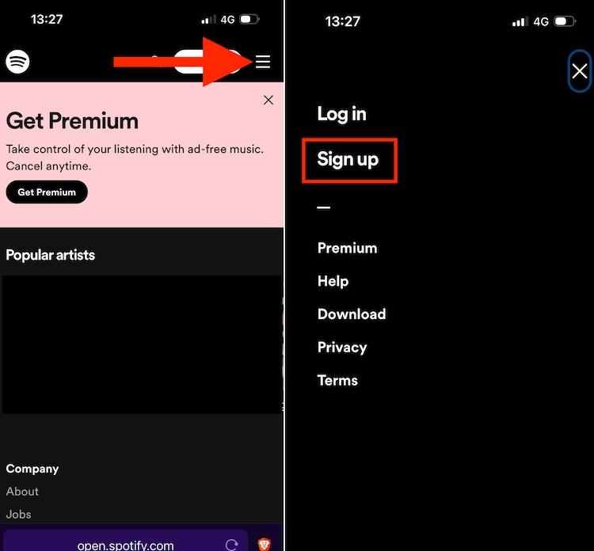
Issue 5: Banner or sign-up prompt covers content
- Device size: Mobile, 390 × 844.
- Problem to check: A fixed banner or sign-up prompt may obscure the bottom of the page or playback controls.
- Suggested solution: Reserve space for fixed elements, account for safe-area insets, and make the prompt dismissible where appropriate.

Summary of recommended fixes
Issue | Recommended fix
Sidebar crowding | Collapsible navigation
Narrow album cards | Responsive grid columns
Playback overlap | Simplified mobile controls
Clipped text | Flexible sizing and text truncation
Banner obstruction | Safe spacing and responsive positioning

Example CSS improvements
The following examples demonstrate techniques that could address these issues if they are confirmed during testing.

